Dry, Wet and Metal waste segregator and smart dustbin

By
Laraib Arshad
- GCWUF- 3421

This report is submitted in partial fulfillment of the requirement for the degree of
BS Computational Physics

Department of Computational Physics
Government College Women University, Faisalabad

Table of contents

Sr no. | Contents | Pages
1 | Introduction | 3
2 | Components of waste segregator kit | 3
3 | Working of dry, wet and metal waste segregator | 8
4 | Significance of segregator | 11
5 | Need for the segregator | 14
6 | Future perspective of waste segregator kit | 16
7 | Applications of dry, wet and metal waste segregator | 18
8 | Innovation in the project | 24
9 | Codes | 26
10 | Circuit diagram | 30
11 | Conclusion | 31
12 | References | 32

Dry, Wet and Metal waste segregator components kit

Introduction
A Dry, Wet and Metal Waste Segregator is a smart system designed to automatically sort household or industrial waste into three main categories:
- Dry Waste – Paper, plastic, cardboard, etc.
- Wet Waste – Organic waste like food scraps and vegetable peels.
- Metal Waste – Aluminum foil, tin cans, etc.
This helps promote effective waste management, recycling, and environmental sustainability.

Components of the Waste Segregator Kit

Microcontroller (e.g., Arduino UNO)

Function: Acts as the brain of the system.
Details: Processes input from sensors and controls the actuators/motors accordingly.
Power: Typically powered via USB or 9V battery.
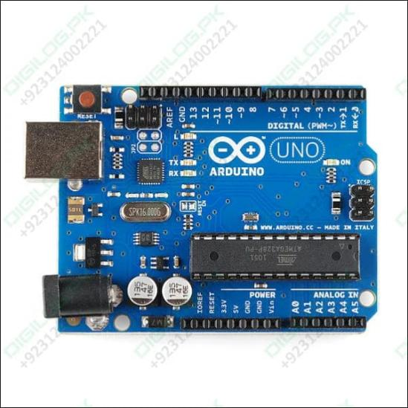
Figure 1: Arduino UNO

2. Sensors

a. Moisture Sensor
Purpose: Detects wet waste based on moisture content.
Working: Measures the conductivity of the waste material; wet waste conducts more electricity.
Output: Analog or digital signal sent to the micro controller.

b. Inductive Proximity Sensor / Metal Detector
Purpose: Identifies metal waste
Working: Uses magnetic fields to detect the presence of metals.
Types: Inductive (for ferrous metals) or capacitive (for all metals).

c. Infrared (IR) Sensor / Ultrasonic Sensor
Purpose: Detects presence of waste and helps align the waste container or sorter.
Working: Sends and receives infrared light or ultrasonic waves.
Use: Triggers sorting mechanism when waste is present.
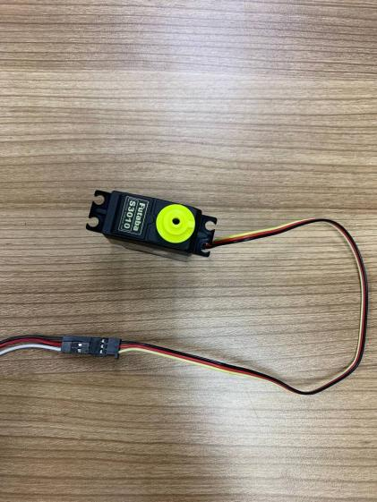
Figure 2: Sensor used in wet, dry and metal segregator

3. Servo Motors / DC Motors
Function: Operates the mechanical sorting arms or flaps.
Details:
Servo Motors: For precise angular movement to direct waste into the correct bin
DC Motors: May be used for conveyor belts or rotating bins.
Control: Managed by microcontroller based on sensor input.

Figure 3: Servo motor

4. Waste Bins / Compartments
Function: Separate physical bins for dry, wet, and metal waste.
Material: Usually plastic or metal; color-coded (green for wet, blue for dry, red/yellow for metal).

Design: Positioned to receive waste based on sensor-based classification.
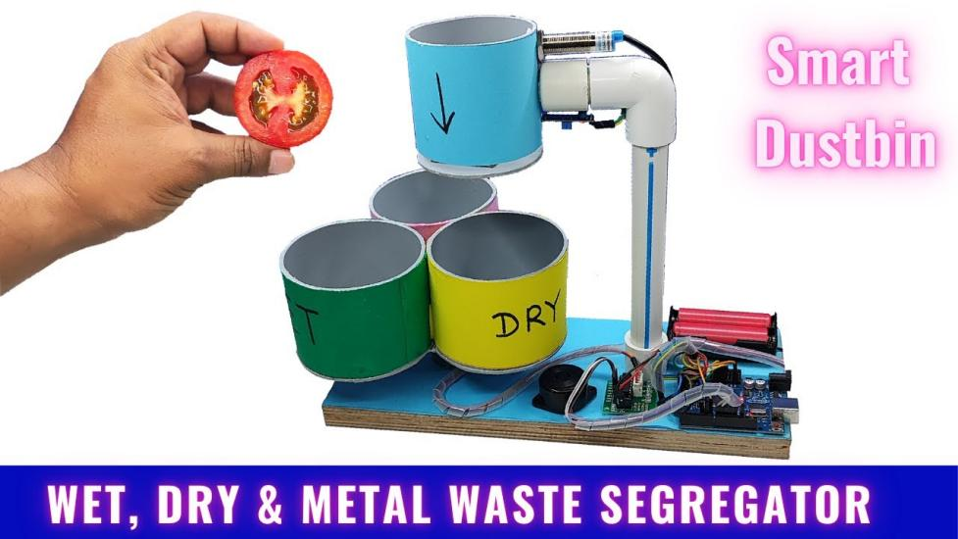
Figure 4: Smart Dustbin

5. Power Supply
Details: Powers the entire circuit (sensors, microcontroller, motors).
Options: Battery pack, AC-DC adapter, or power bank.

6. Chassis / Frame
Function: Holds all components together.
Material: Usually made of acrylic, plastic, or metal.
Design: Custom built to allow for sensor placement, motor movement, and bin access.

7. Display Unit (Optional)
Type: LCD or OLED screen.
Purpose: To display the type of waste detected or system status.

8. Wires, Breadboard, Connectors
Use: For connecting all electronic components.
Includes: Jumper wires, resistors, soldered connections, etc.

9. Software (Arduino IDE)
Purpose: Program the microcontroller.
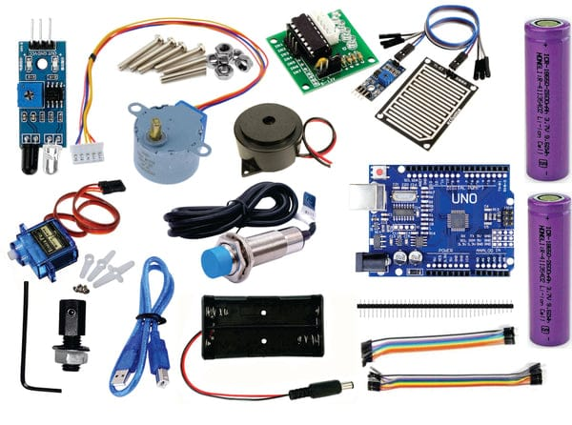
Figure 5: Components of wet, dry and metal components segregator

Working of a Dry, Wet, and Metal Waste Segregator

Step 1: Waste Insertion
- The user drops a piece of waste (e.g., a paper cup, banana peel, or metal can) into the input tray or chute.
- The input tray can be stationary or attached to a rotating mechanism or conveyor belt that feeds the waste to the sensor station.

Step 2: Waste Detection and Identification (Sensor Stage)
The waste passes through a sensor station, where multiple sensors work in sequence to detect the type of material:
- Metal Detection
Sensor Used: Inductive proximity sensor or metal detector.
How it works:
- It generates an electromagnetic field.
- When a metal object enters this field, it disrupts the field.
- The sensor sends a HIGH signal to the microcontroller.
Action: If metal is detected, the microcontroller activates the motor to direct the waste to the metal bin.
No further checks are needed after this for that item.
2. Moisture Detection:
Sensor Used: Moisture sensor (capacitive or resistive).
How it works:
- The sensor probes check for moisture content.
- Wet/organic waste like fruit peels and food scraps conduct electricity well, causing higher sensor readings.
- Dry waste (paper, plastic) shows low or no conductivity.
Action: If high moisture is detected, the microcontroller directs the waste to the wet bin.
If low or no moisture is detected, the waste is classified as dry waste.

Step 3: Waste Sorting (Actuation Stage)
Once the microcontroller identifies the waste type, it sends signals to actuators (motors/servos) to sort the waste:

Option A: Rotating Flap Mechanism
- A rotating disc/flap moves left, right, or center to guide waste into the appropriate bin.

Option B: Conveyor Belt with Pusher Arms
- Waste moves forward on a belt.
- A pusher arm activates based on waste type and diverts it to the correct side bin.

Option C: Rotating Platform
- The input tray rotates to align with the correct bin for automatic dropping of waste.

Step 4: Collection in Bins
The waste is dropped into one of three dedicated bins:
Dry Waste Bin – for paper, plastic, cardboard.
Wet Waste Bin – for food waste, vegetable peels.
Metal Waste Bin – for cans, foil, wires.
Each bin can be color-coded or labeled for ease of use and post-sorting handling.

Step 5: Power and Control
The system is powered by a battery pack or adapter.
The Arduino/NodeMCU/Raspberry Pi processes sensor input and outputs control signals.

Optional Features
Automatic Lid: Opens when someone comes near (using an ultrasonic sensor).
IoT Integration: Sends data to a cloud platform for monitoring waste type statistics.
Voice/Light Alerts: Indicate waste type detected.
Battery level indicator for portable version
Metal detected?
Insert the waste
Start

Sort to metal bin
If metal detected

Added to dry or wet bin
Moisture is determined
If no metal detected

Figure 6: Flow diagram of working of wet, dry and metal waste segregator

Significance of dry, wet and metal segregator

Environmental Significance

a. Promotes Efficient Recycling
- Correct segregation ensures that recyclable materials (like dry plastic and metals) are not contaminated by wet waste.
- This makes the recycling process more efficient and cost-effective.

b. Reduces Landfill Waste

Organic (wet) waste can be composted.

Metals and dry recyclables can be reused.
- This reduces the overall waste dumped in landfills, thereby lowering soil and water pollution.

c. Decreases Greenhouse Gas Emissions

Wet waste in landfills produces methane — a potent greenhouse gas.
- By separating and composting wet waste, the project helps reduce methane emissions.

2. Social Significance

a. Improves Public Health
- Mixed waste attracts pests, releases foul odors, and spreads diseases.
- Proper segregation minimizes these health hazards, especially in densely populated areas.

b. Supports Sanitation Workers
- Manual waste picking is dangerous and unhygienic.
- This system reduces human contact with harmful or sharp objects, improving the dignity and safety of waste workers.

c. Encourages Responsible Behavior
Installing these systems in schools, offices, or public places spreads awareness about the importance of waste management at source.

3. Economic Significance

a. Lowers Waste Management Costs
- Cleanly segregated waste reduces the cost of recycling and disposal.
- Municipalities save money on waste collection, treatment, and landfill maintenance.

b. Creates Marketable By-products

Wet waste can be converted into compost or biogas.
- Recyclable metals and dry waste have resale value, creating a revenue stream.

c. Promotes Circular Economy
Helps transition from a "use and throw" model to a "reuse, recycle, regenerate" model, reducing raw material dependency.

4. Educational Significance

a. Ideal STEM Project for Students
- Integrates knowledge of electronics, environmental science, and programming.
- Encourages hands-on learning and innovation in solving real-world problems.

b. Awareness Tool
- Demonstrates practically how sensor-based automation can help in sustainability.
- Can be showcased in science exhibitions or workshops to raise awareness.
5. Technological Significance

a. Applies Modern Technologies
- Uses IoT, microcontrollers, sensors, and automation.
- Bridges the gap between software and hardware for smart solutions.

b. Prototype for Smart Cities
- Waste segregation is a key part of Smart City initiatives.
- This project can be scaled up for urban waste management systems with real-time monitoring.

c. Foundation for Advanced Projects
- Can be upgraded to include:
- AI-based image recognition (to detect waste visually)
- GSM modules (to alert when bins are full)
- Solar power for sustainability

Needs for wet, dry and metal waste segregator

The following are the few needs for this project:

To Enable Smart Waste Automation and IoT Integration
In smart cities and industries, waste segregation machines can be integrated with IoT (Internet of Things) devices.
They enable automated waste tracking, data collection, and smart bin monitoring, which helps optimize waste pickup routes and schedules.
- To Prevent Occupational Hazards for Sanitation Workers
Manual sorting of unsegregated waste exposes workers to sharp metals, hazardous chemicals, and infectious materials.
A machine-based segregator reduces direct contact with harmful waste and promotes worker safety and dignity.
- To Separate E-Waste Components Efficiently (Especially Metals)
Many metal items, especially in e-waste (like wires, batteries, and old electronics), need to be removed early.
Segregators help isolate these items for special handling, since metals like lead or lithium require proper disposal.
- To Support Industrial and Commercial Waste Management
Offices, factories, hospitals, and malls generate large-scale waste, where manual segregation is not feasible.
Automated segregators can process bulk waste rapidly, ensuring hygiene and compliance in commercial spaces.
- To Prevent Cross-Contamination of Waste Streams
When metal or wet waste contaminates recyclables, the whole batch becomes unsuitable for recycling.
Early segregation avoids cross-contamination, ensuring the quality of both recyclables and compostables.

To Reduce Carbon Emissions in the Recycling Chain

Efficient segregation reduces the transportation and re-sorting efforts needed later.
This directly cuts down on fuel use and carbon emissions during the collection and processing phases.
- To Facilitate Resource Mapping and Circular Economy
When waste is properly segregated, municipalities and companies can better track material flows.
This data helps plan circular systems where waste becomes input for new products, reducing raw material use.
- To Handle Increasing Complexity of Urban Waste
Modern waste is more complex—multilayer packaging, metal-coated plastics, biodegradable plastics, etc.
Advanced segregators are needed to identify and sort these new materials effectively.
- To Encourage Corporate and Institutional Sustainability Goals
Many organizations aim for zero waste to landfill certifications.
Having proper segregation systems (including metal) is essential for meeting ESG (Environmental, Social, Governance) and CSR (Corporate Social Responsibility) goals.
- To Comply with International Waste Standards
For exporting waste materials or meeting global sustainability targets, proper segregation is often legally required (e.g., Basel Convention on hazardous waste).
Metal and e-waste segregation is especially critical for traceability and regulatory audits.

Future perspective for wet, dry and metal waste segregator
The future perspective for wet, dry, and metal waste segregators is promising, driven by increasing global awareness of sustainability, urbanization, and the urgent need for better waste management systems. Here's a breakdown of key future trends and opportunities:
- Growing Market Demand
Urbanization & Waste Volume: As cities grow, waste generation increases, leading to more demand for efficient waste segregation systems.
Government Policies: Many countries are enforcing strict waste segregation rules. For instance, India’s Solid Waste Management Rules (2016) mandate source segregation.
Corporate ESG Goals: Businesses are adopting greener waste management practices to meet environmental, social, and governance (ESG) standards.
- Technology Advancements
Smart Segregators: Use of sensors, AI, and IoT to detect and separate waste automatically (e.g., identifying metal using inductive sensors or AI image recognition).
Data-Driven Systems: Waste segregators integrated with software for data tracking and analytics to optimize collection and recycling.
- Sustainability & Circular Economy
Waste segregators contribute to resource recovery—wet waste into compost/biogas, dry into recyclables, and metal into industrial reuse.
Facilitates zero-waste goals in smart cities and green buildings.

Business and Investment Opportunities

Startup space: Scope for innovation in affordable, user-friendly segregators for homes, apartments, and offices.
Public-Private Partnerships (PPP): Governments are increasingly funding smart waste management projects.
Export Potential: Emerging markets in Africa, Southeast Asia, and Latin America are potential buyers of such technology.

Future Outlook
Time frame | Outlook
Short term (1-3years) | Adoption in smart cities and large institutions will increase. Pilot projects and government incentives likely.
Mid term (3-7 years) | Tech-enabled segregators become common in urban homes and public places. More startups and standardization.
Long term (7-15 years) | Fully automated segregation integrated into municipal systems. AI-driven systems with autonomous waste sorting.

Challenges to Address
- High initial cost of smart segregators.
- User behavior and education in source segregation.
- Maintenance and durability of systems, especially in harsh environments.

Applications of wet, dry and metal waste segregator
Here’s a detailed breakdown of applications for a Wet, Dry, and Metal Waste Segregator, categorized by sector and use-case.

1. Residential Sector

Application:

Apartment complexes, gated communities, and standalone homes.

Use Cases:
- Source segregation at household level: Smart bins that guide users on where to dispose of specific waste types (wet, dry, metal).
- Community-level composting: Segregated wet waste can be used in local composting/biogas units.
- Data tracking: Integration with apps to show residents their recycling stats and compliance.
2. Commercial Buildings & Offices

Application:

Offices, shopping malls, hotels, tech parks.

Use Cases:
- Automated indoor waste segregation using smart bins or chutes.
- E-waste + metal sorting from office waste.
- Sustainability metrics: Tracking waste diversion from landfills for ESG and green certification (LEED, IGBC, etc.).

3. Healthcare Facilities

Application:

Hospitals, clinics, diagnostic labs.

Use Cases:
- Separation of biodegradable (wet) waste from dry packaging and metals (syringe needles, cans, etc.)
- Pre-sorting before hazardous waste disposal.

4. Educational Institutions

Schools, colleges, universities.

Use Cases:
- Student and staff waste segregation education using interactive bins.
- On-campus composting/recycling projects.
- Sensor-based segregators for smart campus initiatives.
5. Industrial and Manufacturing Units

Application:

Factories, assembly lines, metalworking facilities.

Use Cases:
- Segregation at source for metal scrap, recyclable dry packaging, and canteen wet waste.
- Integration with internal waste management systems for reuse and resale.
- Safety compliance through proper waste classification.

6. Retail and Food Industry

Application:
Supermarkets, food courts, restaurants.

Use Cases:

Wet waste segregation for composting (food scraps).
- Dry and metal sorting for packaging (plastic, metal cans, etc.).
- Customer engagement bins in food courts that guide proper disposal.
7. Municipal Solid Waste Management

Application:
Urban and rural waste collection systems.

Use Cases:
- Pre-sorting at collection points using semi-automated or automated segregators.
- Transfer stations using conveyor belts + AI to sort wet/dry/metal.
- Reduction in landfill burden by channeling sorted waste to appropriate facilities (composting, recycling, metal recovery).
8. Hospitality Sector

Application:
Resorts, hotels, hostels.

Use Cases:
- Guest waste sorting systems.
- Kitchen and housekeeping waste segregation.
- On-site waste treatment (e.g., composting of wet waste from kitchens and gardens).
9. Research & Development Centers

Application:
Innovation hubs, environmental research labs.

Use Cases:
- Pilot testing of advanced segregation methods (e.g., AI vision-based sorting).
- Developing new recycling/upcycling methods for sorted materials.
10. Smart Cities & Urban Planning

Application:
Public places: parks, roadsides, bus/train stations, airports.

Use Cases:
- Smart public bins with real-time fill status and segregation features.
- Data aggregation for municipal dashboards.
- Public awareness and behavior nudging via bin interfaces and notifications.
11. Logistics & E-commerce Warehouses

Application:
Distribution centers, packaging units.

Use Cases:

Segregation of packaging waste (plastic, cardboard, bubble wrap, metal staples).
- AI-based material detection in high-speed conveyor belts.
- Sustainability compliance for carbon reporting.

12. Informal Sector Integration

Application:
Integration with waste picker networks in developing countries.

Use Cases:
- Pre-segregated waste makes collection easier and more profitable for informal recyclers.
- Safer working conditions through reduced exposure to mixed waste.

Optional Features that Enhance Applications

AI image recognition + sensors for identifying materials.
- Fill level sensors and odor detection.
- Integration with municipal CRM systems.
- Reward or incentive systems for correct usage (e.g., in smart cities).

Innovations that make our project unique

Smart Decision Engine with Multi-Sensor Fusion

Innovation:

Combine gas sensors (for organic decay), inductive sensors (for metal), IR sensors (for plastic), and load cells (weight) to make better decisions.

Differentiator:
Provides higher accuracy and context-aware segregation by cross-verifying multiple data inputs

Mobile App + IoT Integration

Innovation:
A user-facing mobile app that shows:
- Real-time waste stats
- Notifications (e.g., bin full, improper waste)
- Rewards system for responsible disposal

Differentiator:
Encourages behavioral change and turns the bin into a data-driven system

Precision Metal Detection and Sorting

Innovation:
Use advanced eddy current sensors or magnetic separators that can sort ferrous and non-ferrous metals.

Differentiator:
Most systems do basic metal detection; yours can separate aluminum, steel, copper—increasing resale value and recycling qualitY

Waste Type Tracking and Compliance Reports

Innovation:

Automatically generate monthly reports on the types and quantities of waste disposed by type (wet/dry/metal).
Differentiator:
Ideal for institutions, smart cities, and ESG compliance. Can integrate with platforms like LED or Green Building Certifications

Noise-Free and Low-Energy Operation

Innovation:
Use silent stepper motors and low-power microcontrollers for operations.

Differentiator:
Makes the machine viable for indoor and office use—quiet, energy-efficient, and low maintenance.

Cloud-Based Waste Analytics Dashboard

Innovation:
Admin dashboard for housing societies, institutions, or municipalities showing:
- Waste trends
- Bin usage patterns
- Environmental impact estimates (e.g., CO₂ saved, landfill diverted)

Differentiator:
Provides data visibility at scale, useful for policy-making and budget planning.

Codes:
#include <CheapStepper.h>
#include <Servo.h>
Servo servo1;
#define ir 5
#define proxi 6
#define buzzer 12
int potPin = A0; //input pin
int soil=0;
int fsoil;

CheapStepper stepper (8,9,10,11);

void setup()
{Serial.begin(9600);
pinMode(proxi, INPUT_PULLUP);
pinMode(ir, INPUT);
pinMode(buzzer, OUTPUT);
servo1.attach(7);
stepper.setRpm(17);
servo1.write(180);
delay(1000);
servo1.write(70);
delay(1000);}

void loop()
{fsoil=0;
int L =digitalRead(proxi);
Serial.print(L);
if(L==0)
{tone(buzzer, 1000, 1000);
stepper.moveDegreesCW (240);
delay(1000);
servo1.write(180);
delay(1000);
servo1.write(70);
delay(1000);
stepper.moveDegreesCCW (240);
delay(1000); }
if(digitalRead(ir)==0)
{ tone(buzzer, 1000, 500);
delay(1000);
int soil=0;
for(int i=0;i<3;i++)
{ soil = analogRead(potPin) ;
soil = constrain(soil, 485, 1023);
fsoil = (map(soil, 485, 1023, 100, 0))+fsoil;
delay(75); }
fsoil=fsoil/3;
Serial.print(fsoil);
Serial.print("%");Serial.print("\n");
if(fsoil>20)
{stepper.moveDegreesCW (120);
delay(1000);
servo1.write(180);
delay(1000);
servo1.write(70);
delay(1000);
stepper.moveDegreesCCW (120);
delay(1000); }
else { tone(buzzer, 1000, 500);
delay(1000);\
servo1.write(180);
delay(1000);
servo1.write(70);
delay(1000);}

Circuit diagram:
The circuit diagram is given below:
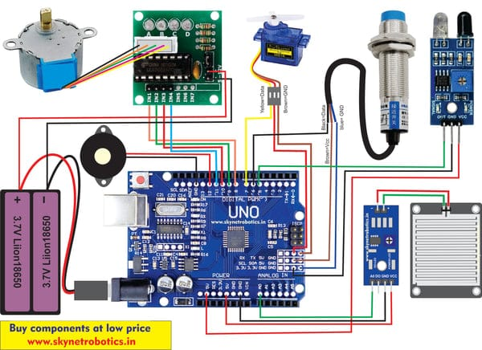
Figure 7: Circuit diagram of wet, dry and metal waste segregator

Conclusion

- In conclusion, the Wet, Dry, and Metal Waste Segregator presents a practical and efficient solution to one of the most pressing challenges in modern waste management—effective segregation at the source.
- By automating the classification of waste into wet, dry, and metallic categories using sensors and microcontroller-based logic, the system significantly:
- Reduces human intervention and error
- Enhances recycling efficienc
- Promotes environmentally sustainable practices
- The project not only demonstrates the application of basic engineering principles and sensor technology but also emphasizes the importance of innovation in solving real-world problems.

References
- https://youtu.be/4XedfXtPxLQ?si=Xk4r9KDQTfhrIey4
- Reddy, M. K., Meher Phanideep, D., Balaji, V. R., Kumar, S. C., Jaldu, V. S. P., Motamarry, S. M., & Vineeth, C. (2023, November). Smart dustbin for real time waste segregation and monitoring. In AIP Conference Proceedings (Vol. 2946, No. 1, p. 040010). AIP Publishing LLC.
- Shiny, S., Meeran, M. S., & Rajeshwaran, S. (2018). Smart Dustbin-Wet and Dry (Metal) Waste Segregator with Alert System. International Journal of Creative Research Thoughts (IJCRT), 6(1), 931-934.
- Punglia, P., Bansal, S., Kumar, R., & Rani, M. (2023). Fabrication of Smart Dustbin with In-built Wet and Dry Waste Segregator. PRATIBODH, (RACON).

